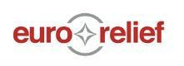

Volunteer Manual

1. About Euro Relief p.1
2. Camp Life p.2-12
3. Cultural Considerations p.12-23
4. Asylum procedure p.26-29
5. Language p.30-32

This material has been provided by EuroRelief and was written by several volunteers of different backgrounds and perspectives. It is based on their experience and findings, so while it is far from exhaustive, it offers a well-rounded insight and will hopefully encourage you to ask further questions. Suggestions or remarks about the content are welcome.

# About EuroRelief

EuroRelief Hellas is a Greek, Nonprofit, Non-Governmental Organization that was founded in 2005. EuroRelief was first deployed to Kalamata, Greece, because of this area having experienced powerful earthquakes. In response, EuroRelief sent teams that provided mobile homes for earthquake victims. In the years that followed, more teams were sent to help after disasters in other countries.

In September 2015, EuroRelief started work on Lesvos. Since 2015, EuroRelief has had opportunities to work in Skala Sykamnias (Northern part of Lesvos) and later in Moria. Gradually the funding from European Union to other NGO’s decreased and many organizations left the island or Moria. EuroRelief in Moria is providing shelter allocation, non-food items supply and distribution, is operating an information center, providing-care takers for the unaccompanied minors section, carrying out maintenance, cleaning facilities, creating activities for men/women/children, guarding gates and is doing most of the day to day work in Moria. EuroRelief normally has about 100 volunteers on Lesvos at a time.

There are five paid employees working for EuroRelief: Stefanos Samiotakis (director of EuroRelief), Christos Vasileiou (IT/Communications), Anna Stambouli (administration), Litsa Argyri (finances), Giannis Haritonidis (accounting). All of our people with a EuroRelief badge in Moria are volunteers. EuroRelief’s only source of income is private donations. Our values derive from the Bible and we seek to live them out as part of our faith in Jesus. Our goal is to serve people in need like refugees and migrants, but also the local population wherever we operate.

Camp Moria

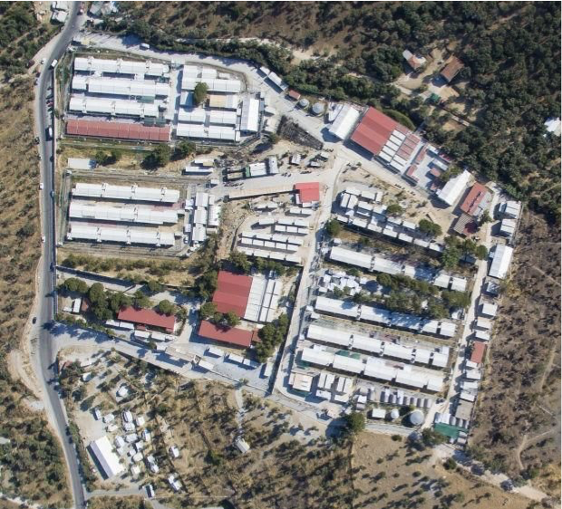While it’s easier to say “refugee camp” when talking about Moria, this is technically an incorrect title. Moria is classified as a “Hotspot”, not a “Refugee Camp”. The details of this sub-classification are complicated and beyond the scope of this handbook. However, it’s important to note the distinction because, as a hotspot, Moria is subject to more limited government assistance and a higher influx of asylum applications to process. This creates a very congested living environment with  
resources to improve infrastructure of the  
Simultaneously, the asylum authorities  
are overwhelmed with a mass of applications to process. These factors are some of the greatest contributors to the strife and tension among the inhabitants of Moria.

Further research:

https://www.ecre.org/wp-content/uploads/2016/12/HOTSPOTS-Report-5.12.2016.pdf

**Camp Management**

The entire compound of Moria is a military owned facility, with a small, active military base adjacent to the camp. While the military has a presence in the camp and some limited functionality in the operation (providing meals, controlling power and water...), the day-to-day administration of the camp is civilian run. The director of the camp, Giannis Balpakakis, and his immediate staff work in conjunction with the Greek Military, the Moria Police Department, Asylum Services, and the various NGO Site Coordinators to ensure the proper oversight and control for Moria.

NGO Presence

Until the summer of 2017, there were several NGO’s (Non-Government Organization) operating inside Moria. At that time, ECHO (European Civil Protection And Humanitarian Aid Operations) cut back funding to the major actors working inside all camps and hotspots across Greece. Spearheaded by ECHO, the EU administration transitioned humanitarian aid distribution away from individual NGO sources. Instead, the MPG (Multipurpose Cash Grants) program was implemented across Greece. This means that each migrant is issued a “cash card” upon which ECHO deposits a certain amount of Euros (based upon socio-economic standing such as marital status or age) in order for the migrant to have the monetary resources necessary to acquire their basic needs.

This move reallocated the funding that was previously going to the NGOs directly into the cash card program, leaving many of the major NGO’s operating within Moria without the necessary financing to continue their work. EuroRelief’s operation, shelter allocation, is still considered necessary to ECHO’s emergency response plan for Greece. Therefore, EuroRelief is still able to continue their work within Moria. However, the transition toward cash cards has affected the way in which EuroRelief operates to some extent within the camp. For example, we are not able to simply distribute NFIs (non-food items, hygiene products) to the general population of camp as we were doing previously, because NFIs should now be purchased with cash card money. Additionally, EuroRelief is not funded through ECHO. All of EuroRelief’s operations are sustained through grants and donors.

Further Research:

https://ec.europa.eu/echo/sites/echo-site/files/dg_echo_esop_2017_second_round_v2.pdf

Find below some Greek government entities operating in Moria camp:

**Greek Government**

* RIC: RIC (Reception and Identification Center) of the Ministry of Migration Policy, General Secretariat of Reception. Moria camp is managed by RIC. The camp manager (Giannis Balpakakis) is a staff member of RIC.
* Greek Military: Moria is a Greek Military installation. Neither volunteers nor refugees interface directly with the military on a daily basis except for in the distribution of food in the lower sections of camp.
* Police: The police in camp Moria exist to provide security to refugees and volunteers, as well as to call the ambulance in the case of an emergency. This is their only official duty in camp.
* GAS: The Greek Asylum Services (GAS) is in charge of the interview process whereby refugees are granted or denied asylum into Greece. They are located in the EASO area.
* Kelpno: Kelpno is the first medical service most refugees encounter, doing the initial health screening for New Arrivals to Moria and providing them with their doctors papers. Kelpno is the ​***ONLY*** ​​medical service which may issue a vulnerability status.

There are also a few NGOs actively working inside Moria, they’re listed below:

**Medical**

* BRF: Boat Refugee Foundation provides emergency medical services from 4.30PM – 11PM Sunday - Friday. BRF only sees emergencies, and should not be used as a primary healthcare provider.
* Kitrinos: Kitrinos is the primary healthcare provider in Moria, and provides diagnosis and (when possible) treatment of basic ailments and injuries. Kitrinos operates from 8AM – 4PM Monday - Friday.
* MSF: Medicines Sans Frontiers (MSF), or Doctors Without Borders, provides medical care for children 0-16 years old, pregnant women, and women up to two Months after delivery. MSF also provides care for victims of sexual assault if the assault has occurred in the past five days. MSF is located in the large mobile clinic outside of Moria.
* Rowing Together: Rowing Together assists with gynecology services for pregnant women and all types of women. They have a clinic equipped with an ultrasound machine, a medical team, consisting of gynecologists, midwives, pediatricians and nurses.

**Legal**

* DRC: Danish Refugee Council (DRC) provides legal council and protection monitoring to refugees. Legal services are available by appointment only, and appointments can be made at the DRC office by EASO 9AM – 4PM Monday - Friday. More information is available at the DRC office.
* ELIL: European Lawyers in Lesvos (ELIL) is a volunteer organization which provides free legal services to refugees and helps them prepare for their interview. Refugees do not need an appointment, and translators are provided. ELIL is open from 10AM – 5PM Monday - Friday.
* Praxis: Praxis created the ‘Emergency Temporary Accommodation Scheme for Unaccompanied Children’ at the MSF transit camp in Lesvos. The overarching objective of this emergency intervention is the transfer of unaccompanied children from detention conditions and their temporary (transit) accommodation and care at an open and safe facility, which takes into account their particular vulnerability.
* Metadrasi: Metadrasi offers specially trained interpreters in 43 languages and dialects to provide vital communication with refugees, legal support, and certification of victims of torture. It also escorts unaccompanied and separated children (UASC) from border detention centers to appropriate accommodation facilities throughout Greece and operates Transit Accommodation Facilities for UASC.

**Administrative**

* IOM: International Organization for Migration (IOM) oversees the voluntary self-deportation process. Refugees interested in the possibility of self-deportation should go to the IOM office in the RIC for more information.
* UNHCR: United Nations High Council of Refugees (UNHCR) provides legal information to refugees, and administers transfers from Moria to other housing sites in hotels, Kara Tepe, and on the mainland of Greece. Refugees with questions about family reunification, reconciling the case numbers of married couples, etc., should go to the UNHCR to seek help. Refugees with vulnerabilities should be directed to the UNHCR to have their names added to transfer lists. Refugees should go only to the UNHCR Info Point outside of the RIC area near the New Arrivals cage.
* EASO: European Asylum Support Office (EASO) conducts interview on behalf of GAS (see above), and issues recommendations (which are almost always taken) as to whether or not a case should be accepted by GAS or not. In Moria, EASO is essentially the face of GAS to refugees.

**Other**

* EuroRelief: EuroRelief assigns housing in Moria, oversees the New Arrivals area and works in Sections A, B, & C, in addition to doing miscellaneous other services and Non-Food Item (NFI) distributions.
* REMAR: Fundación Mensajeros de las Paz (Messengers of the Peace Foundation), which is generally referred to as REMAR, is in charge of the food distribution in “upper camp,” including all of camp except for Olive Grove, New Arrivals, and Sections A,B, & C.
* BRF: Boat Refugee Foundation provides psychosocial services to refugees, including basic language classes, stress relief classes, etc. BRF is located near EASO, and a full schedule of services can only be found at their office.
* MOTG: Movement on the Ground (MOTG) manages the lease for Olive Grove, where they oversee the distribution of food and are involved in some improvement projects.
* ICRC: International Committee of the Red Cross provides sea rescue services, and also provides logistical and legal services to people who are eligible for the [Dublin Agreement](https://www.unhcr.org/4a9d13d59.pdf) family reunification process.
* HELP International: HELP International provides activity services and educational programs to the unaccompanied minors who live inside Section A of the RIC area.

EuroRelief Roles and Operations

Roles

**Shelter Allocation**

Within Moria, EuroRelief’s primary responsibility is to provide shelter allocation to all incoming migrants. This means that everyone who is registered to the hotspot of Moria requires a designated place to live in camp, and EuroRelief is responsible for assessing, securing, and assigning these locations for everyone. This process is not as simple as it sounds, and is vital for maintaining order and structure within Moria. Fortunately, the leadership of EuroRelief has extensive experience working with shelter allocation and provides basic, often step-by-step, instruction to volunteers on the best and most effective way to “house everybody” inside Moria.

**New Arrival NFI Distribution**

When the majority of NGOs departed from Moria, EuroRelief inherited the responsibility of managing the new arrivals area. We allocate them an area to sleep temporarily within the arrivals area. We distribute food and water until a place is found in the camp for them to move into. During this time they are each issued a set of clothing, a hygiene pack and bedding.

**Protection**

One of EuroRelief’s largest roles in camp is supporting protection for vulnerable cases by guarding the gates of various sections in camp. We support protection to the entire Lower Levels of camp (Registration and Identification Center (RIC) area, Section A, Section B, and Section C) through various protection measures. The Main RIC gate is only open to people who have a reason to be in the RIC area (they work there, they live there, they have an appointment...) and it is the responsibility of the person “guarding” the RIC gate (usually a Greek policeman) to ensure that access is allowed only to authorised people. Sections A, B, and C are designated housing for the most vulnerable people in camp (single women, unaccompanied minors, families, people with health disabilities, LGBT cases, trafficked cases...). Each person who lives in one of the lower sections has a specific ID card that grants them access to their section, and all others are not permitted entrance. It is the responsibility of the gate guard at each of these sections, to enforce this protection measure, and to report back any problems to the Shift Coordinator who will then handle the problem. EuroRelief provides guards for Sections B and C in the evenings and weekends.

Gate guarding can be a monotonous task. However, what someone puts into their task is what they will get out of it. Guarding gates is also one of the best opportunities to get to know the people who live in camp. More importantly, providing safety and protection to people who need it, is one of the main reasons why we strive to work with such excellence in Moria.

**Warehouse**

The NFIs are stored in the warehouse. When new donations of clothing come in, they are sorted by volunteers here. The clothing packages (a set of clothes, socks and new underwear) for the new arrivals are also made here.

**Activities**

In order to deter some of the more destructive activities available to the migrants (drinking, smoking, drugs…), EuroRelief regularly provides some form of entertainment in the evenings. When able, we will show popular football games (soccer, for the Americans), other sporting events, movies, dance parties, or anything else fun that will pique the interest of the people living in Moria. Additionally, we provide sporting equipment (balls, nets, goals…) that the people check out and use throughout the day.

Women’s Day is another activity that EuroRelief participates in at the GEM community center close by camp, where our female volunteers host a morning of crafts, beauty activities, food, and games for the women who live in Moria. These women are often overlooked within their own cultures. Women’s Day is an opportunity for them to separate themselves just a little bit and receive pampering and affection from the female staff and volunteers.

**General Camp Management Assistance**

As the largest and most active NGO working within Moria, EuroRelief often becomes the “catch-all” for tasks or roles needing to be filled in order to continue the safe and healthy operation of the camp. This can include anything from camp maintenance, transporting people to neighbouring camps, special protection, administrative tasks, or anything else that helps maintain order within Moria.

**Volunteers**

One of the best assets that EuroRelief brings into Moria is the large number of volunteers who have come from all over the world to serve these people. Moria is undoubtedly a very challenging environment to work in. Therefore, it is important that volunteers prepare themselves effectively, so that they can be most successful while serving. The best way to prepare you as a volunteer is to tell you to put aside any expectations for this experience. There is no way to accurately describe what life in Moria is like; the best way to learn is to come see for yourself. However, when you come - be teachable, be open-minded, ask questions before criticizing, and gain a proper understanding of what is happening in this crisis.

Operation

**Shift structure**

EuroRelief divides its workday into different shifts.

08.00-17.00 (morning) - this shift will often extend past 1700 depending on workload

16.00-00.30 (evening)

00.00-09.00 (overnight)

Each day a group of people are scheduled to work in EuroRelief’s warehouse (08.00-17.00).  
The morning and evening shifts are supervised by a shift coordinator, and are the shifts where the bulk of the work happens. The overnight shift comprises a skeleton crew of volunteers who provide gate control and camp oversight during sleeping hours. At the beginning of each shift all the volunteers will be briefed by a coordinator about what is expected for the shift. Job assignments will also be delegated at this time.

**Downtime**

While Moria has an overwhelming number of needs, often times the work comes in waves. There will be shifts where the task load seems insurmountable and there will be shifts where it seems that nothing is going on anywhere in camp. While these more lethargic shifts come as a welcomed break for the long-term staff, short-term volunteers can struggle with not feeling useful in the stagnation. However, it is important that volunteers still take advantage of these moments, being proactive seeking out ways to serve the people of Moria. Many times, simply asking the shift coordinator if there is anything that can be done is the best way to learn what small tasks are most needed and often overlooked in the craziness.

*Disclaimer: many times these jobs are the least desirable tasks (i.e. picking up trash, cleaning bathrooms, organizing storage containers*... *but still their importance cannot be overstated).*

Another way to fulfill the downtime is to use these moments as opportunities to spend time with the people who live in Moria. It can be difficult to spend purposeful time with the people you’re serving during the times of high-intensity workloads. When able, playing sports, sharing a cup of tea, or simply walking around camp saying “hello” can go a long way in lifting spirits and provide opportunities for you to spend quality time with the people you came to serve.

EuroRelief Leadership Roles

**Moria Site Coordinator**

The Moria Site Coordinator is responsible for directing the entire work of EuroRelief within Moria. He regularly meets with the camp director to facilitate camp needs. He provides instruction and direction for the work of EuroRelief to his Shift Coordinators, so that all the work EuroRelief is responsible for, gets completed as necessary.

**Moria Shift Coordinator**

The Moria Shift Coordinators are responsible for managing the entire operation of EuroRelief during one of the three shifts per day. They report directly to the Moria Site Coordinator, and are the first point of contact for all operational instructions and questions throughout the shift. They are also the first point of contact for all emergency situations, unless the Site Coordinator is in camp.

**Moria Housing Coordinator**

The Moria Housing Coordinator is responsible for managing the day-to-day housing assignments throughout the shift. They are also responsible for tracking all data accuracy and preparing major population shift projects that occur throughout the course of the year, as differing nationalities of new arrivals enter Moria.

**Member Care/Training**

The member care/training person is responsible for providing initial orientation training to everyone who arrives as a first-time volunteer through EuroRelief. This training will be comprehensive, covering both how we do our jobs, and why we work the way that we do. Additionally, this person regularly checks in with volunteers throughout their time to ensure general health and satisfaction working in Moria. This person reports up to the shift coordinator, and ultimately up to the site coordinator.

**NFI/Warehouse Manager**

The NFI/Warehouse manager is responsible for ensuring that EuroRelief possesses all the required NFI items for any upcoming distributions. This includes hygiene kits for new arrivals, clothing for both new arrivals and the general population, bedding items for shelter allocation, and a myriad of other NFI needs that arise.

**Volunteer Coordinator**

The volunteer coordinator processes all applications to serve with Eurorelief and communicates with incoming volunteers, providing them with the information and tools necessary for their arrival and stay on Lesvos.

**Scheduling Coordinator**

The scheduling coordinator prepares the shift schedule for the teams and individual volunteers working through EuroRelief, and distributes the schedule on time so that everyone is aware of what time and when they are expected to be working in camp. They are the first point of contact for all scheduling needs/requests while serving through EuroRelief.

**Maintenance Coordinator**

The maintenance coordinator is responsible for facilitating all maintenance tasks required for EuroRelief. This includes tool tracking, item procurement, project development, and emergency response repairs.

**Caretakers - 1-3 month volunteers**

Caretakers are placed in either New Arrivals, Section B, or Section C and function as a caretaker of the area, working with local staff to provide increased control and protection over the section. They are to be consulted along with the shift coordinator for all questions regarding work in the area (gate guarding, housing, NFI distribution, and food distribution…).

**Caseworkers - 1-3 month volunteers**

Caseworkers are divided among target people groups within Moria. We have caseworkers for unaccompanied single women, unaccompanied men and minors, and families. The caseworkers are responsible for further investigating suspicious situations that arise during the day-to-day work within Moria, and reporting these situations to the appropriate authorities.

**Special Projects Coordinator**

The special projects leader is responsible for managing and developing the short-term projects that happen on-site in Moria. They are also responsible for assisting the housing coordinator for day-to-day housing tasks.

EuroRelief Rules/Culture

The culture of Moria is strikingly dissimilar to anything most volunteers and aid workers have previously encountered.  
Within the 200 x 500 meter compound (about the size of a large department store), there are over 40 different nationalities that make up the 5,500-8,000 person population, each with unique sub-cultures, languages, religions, and customs. Navigating this extremely diverse demographic requires operational guidelines and rules that aid workers often find uncomfortable or unnatural to abide by. However, these rules and guidelines have been devised through experience working in this environment, and should be followed and respected completely.

The inhabitants of Moria are not only from dramatically different cultures than most of our volunteers. Many have also experienced extremely tragic events that have induced psychological traumas, making them highly “vulnerable” people. This vulnerability manifests itself in several ways, most noteworthy, in the way they build relationships, specifically with volunteers. The POC’s (Person of Concern, a less stigmatizing term for refugees, and the “official” title for refugees and migrants in the Greek system) are at risk of emotionally attaching themselves to the volunteers to fulfill the desire for affection and stability that so many of them lack. Setting proper boundaries in conduct is crucial for ensuring the relationships built with POC’s are healthy for both the volunteer and the POC.

*This relationship guideline is* e​xtremely *relevant incross-gender relationships built between POC’s and volunteers. Many of the POC’s are from cultures where friendly cross-gender relationships do not exist. Successfully introducing this relationship form to people in such a delicate emotional state is nearly impossible. Often, the POC’s will develop deep romantic feelings for volunteers who do not share the same sentiment, and can be harmful for both parties. For this reason, it is exceedingly important that volunteers remain vigilant to the way they are conducting themselves while working in Moria.*

*Our goal is that our female staff and volunteers exhibit a professional and friendly cross-gender relationship equally to all POC’s in camp. As women working in this environment, you have the opportunity to be the very first example of what a healthy friendly relationship looks like. This is a really exciting opportunity that should not be disregarded! The best way to do this is treat everyone in camp with kindness as equally as possible.*

While it’s impossible to create a guideline for every situation that volunteers will encounter in Moria, we have some basic rules that we expect our volunteers to adhere to during their time with EuroRelief. They are listed in detail below:

**Rule: No social media interaction with POC’s of the opposite gender.**

*Do not:*​ Text, Facebook, Instagram, Twitter, LinkedIn, Snapchat, WhatsApp, or any other form of social media with POC’s of the opposite gender  
*Do:*​ Same gender: we advise to exchange email addresses. Opposite gender: focus on brief, friendly and professional conversation while in the environment of camp

*Why:*​ Email is preferred for same-gender communication because the volunteer has greater control over the content that is shared with the POC’s. Photos and posts shared on volunteer’s social media often include items or experiences that the POC’s will never get a chance to participate in, and can create emotions of jealousy and hopelessness that are unnecessary and unintended.

Overall, this rule is primarily for the protection of the female volunteers who can get trapped in unhealthy high-pressure conversations where POC’s seek to satisfy the void for personal relationship that many lack.

**Rule: No extended one-on-one interaction with POC’s of the opposite gender**

*Do not:*​ Do not spend extended periods of time with the same POC of the opposite gender. Do not allow yourself to become “attached” to one specific person of the opposite gender.  
*Do:*​ Be equally friendly and kind to everyone you come in contact with. If you find yourself in a situation where you cannot leave the conversation (gate guarding is a common place where many people struggle with this) it is perfectly acceptable to direct the conversation to someone else in the area, or to limit your interest in the conversation until they leave. You may also ask the shift coordinator for a replacement at any time.

*Why:*​ ​​Devoting specific attention to one POC of the opposite gender gives the wrong impression for motive behind the special interest. The POC will almost always derive this attention to be of a special or romantic nature, no matter how many times the volunteer specifies to the contrary. The phrase “actions speak louder than words” holds very true in this situation. If you do not want someone to think you are especially interested in them, do not spend an especially higher or isolated amount of time with them over others.

**Rule: Avoid physical contact with a POC of the opposite gender.**

*Do not:*​ ​​Kiss, hug, side hug, hand holding, sitting up against each other, leaning on each other and pretty much every other form of physical contact other than a handshake or high five.  
*Do:*​ ​​​Handshakes or high fives are ​*encouraged*​, and an excellent way to show kindness!

*Why:*​ ​In Middle Eastern cultures the segregation between men and women is substantial, especially when contrasted with western cultures. Men and women do not eat together, they do not socialize together, they do not worship together, they do not recreate together... In some of the most traditional regions men and women do not even share eye contact.

In western cultures friendly relationships of the opposite gender are normal and encouraged. Blending the two cultures in an environment where relational vulnerability is so prevalent ​*will not work* and is not healthy for either party involved. Cross-gender physical contact is so foreign to the POC’s that it will almost always induce an unwanted attachment toward the volunteer.

**Rule: No distribution of religious literature**

*Do not:*​ ​​pass out Bibles, Qurans, other religious texts, pamphlets, tracts, handwritten letters with references to religious texts, or any other religious literature.  
*Do:*​ ​​If you meet someone who would like a copy of a Bible (we are an organization with Christian values), you should get that person’s information and then share this with a shift coordinator. The shift coordinator will take the information and pass it along to the site coordinator who has the ability to make the decision to get that person the Bible. All POC’s are welcome to visit an offsite community center called “Oasis” (This center is registered under a Greek mission organization: Hellenic Ministries) or the adult community center run by GEM, and receive a free Bible in any of the major languages spoken in Moria. You may invite the POC to visit “Oasis” or GEM center (rides are provided). Ask the shift coordinator for more specific details.

*Why:*​ This is a government-controlled facility. The distribution of any literature in the camp should happen only if there is a relevant decision by the Greek authorities.

**Rule: Never promise something or lie about anything**

*Do not:*​ Do not make up an answer to a question if you are uncertain, tell someone you will give them an item before you have asked permission, give an answer on someone else’s behalf, share plans for the future without permission, or any other form of statement of intent that you cannot personally guarantee.

*Do:*​ Ask your supervisor for the answer to questions. There is no such thing as asking too many questions to the shift coordinators. There is a high turnover rate for volunteers, and the coordinators are very accustomed to repeating answers multiple times. It is better to take the time to answer correctly the first time, than to put the coordinators in a position of having to deliver on false promises from volunteers.

*Why:*​ You don’t know what the future holds. Circumstances in Moria change frequently and unpredictably. Do not create false hope.

**Rule: Do not raise your voice or respond to people in anger and frustration**

Don’t: Yelling, screaming, cussing (in any language), insults, or other derogatory speech will not be tolerated by EuroRelief volunteers or staff.  
Do: ​When tense situations arise, take a deep breath before responding, ask to take a break from working, or simply have someone else deal with the problem. Control the situation through calm words and rational thought.

*Why:*​ ​A soft answer turns away wrath, but a harsh word stirs up anger.  
Frustrating asylum services, poor camp conditions, personal suffering, and a myriad of other problems are elements that POC’s must struggle with on a daily basis. It is very common for POC’s to become enraged toward aid workers for reasons that have little to do with the subject at hand. Your job, as the non-vulnerable volunteer, is to be a stabilizing force in this situation. They may lose their temper, scream, and say a host of unpleasant things to you, but you must not respond in kind because this does not help the POC in any way.

**Rule: Don’t run in camp**

*Do:*​ If someone in authority tells you to run, please run very quickly. Otherwise, walk when in camp. However, skipping, lunges, backpedaling, shuffling, and any other form of movements are amusing and encouraged.  
*Why:*​ ​We don’t need to create a situation of unrest. If people see you running they will assume there is a problem and become unnecessarily concerned.

**Rule: Females always take an exit buddy. The female Shift Coordinators are the ONLY exceptions to this rule**

*Do not:*​ Females should not travel throughout camp alone, unless specific permission has been given from the coordinator. Males should try to always travel in pairs as well, even though it is not a specific rule.  
*Do:*​ ​Travel in groups of two or more throughout camp.

*Why:*​ ​This is an order from the police. Your safety is our highest priority.

**Rule: Do not take photographs or videos while inside camp for any reason**

*Do not:*​ Do not take any photographs or video while inside camp. This includes taking pictures or video of the exterior of camp. Additionally do not “check-in”, post photos, or associate yourself with Moria Camp on social media for any reason!  
*Do:*​ If you really want to capture something occurring inside camp, ask the shift coordinator for guidance.

*Why:*​ It is a regulation by the Ministry of Migration, the managing authority in Moria camp. If someone is caught taking photographs or video in Moria camp might be arrested by the police. Consider detaching yourself from your phone and personal electronics and focus on the people around you while in Moria. You will not be given the Wi-Fi password (unless you have a specific reason, like a team leader) and the cell service is poor throughout camp, so there is very little reason to be attached to your phone.

**Rule: Sign out on the white board, wear a vest and badge at all times, and carry a radio when able.**

*Do not*:​ Whiteboard: do not forget to update the board! It is an easy thing to forget, but it is extremely important for your safety and for smooth operation as an organization.  
Radio: Do not forget to carry a radio. Do not put it in your pockets, bag, or any other location that makes it hard to hear and easy to forget. Do not say unprofessional things, or trigger words (fight, riot, knife...) over the radio.

*Do*:​ Whiteboard: there is a whiteboard at the info office. Write your name and job assignment at the beginning of the shift and update anytime your job assignment changes throughout the shift. Vest: bright orange vest are making a comeback in the fashion world, wear yours at all times. Radio: carry a radio whenever on a job away from the office. Carry it in a way that you can hear it. Respond quickly and professionally to all radio calls.

*Why:*​ ​Whiteboard: Your location should always be clearly known for your safety and for our ability to carry out our work  
Vest: having a common appearance allows POC’s and other aid workers to quickly identify EuroRelief personnel, and enhances professionalism in camp. Also, the bright orange color makes volunteers very easy to spot and assist in emergency situations.

Radio: a constant high level of communication between volunteers and supervisors makes the work of EuroRelief run much smoother, and enhances the safety of everyone in camp.

**Rule: Treat every POC and person in camp with the highest respect**

*Do not*:​ Do not say mean or deriding comments to any person for any reason. Do not use disdainful tones or body language when interacting with others.  
*Do*:​ Be intentional with the words and tone you use to promote positivity and understanding. *Why*:​ Our work is our greatest witness. How we work is far more important than the specific tasks we accomplish.

Cultural Considerations

The European Refugee Crisis has brought cultures into contact which otherwise might never have met. People from remote villages in Central Asia may now live next to someone from the jungles of the Congo. On the other hand, many cultures which have long histories of conflict are similarly now forced to live together, so people may literally be forced to live in the same tent as people who in their home country they would have counted as mortal enemies.

When volunteers walk into Moria we are walking into hundreds of years of history, and we must take time to understand the different cultures, and how they interact. On the first day this may seem overwhelming, but in time you will be able to notice some differences between Afghans and Arabs, and the differences between the nations, ethnicities, and cultures will become more familiar. The distinctions and internal politics of each of these nations goes far beyond our ability to explain in the following pages, but this section will attempt to explain the major cultural affinity clusters you will encounter in camp.

Keep in mind that you will be interacting with people from many different cultures. The more you educate yourself about these cultures, the better you will be able to communicate and your job will go more smoothly. Practice active listening and learn from everyone you meet.

Major Affinity Clusters

The social situation in camp is complicated by many factors. While everyone has one nation of origin on their identity card, this does not explain the depths of their cultural and ethnic background. Daily life in camp is informed by religious, cultural, national, linguistic, historical, and political factors, just to name a few. Ethnic and linguistic boundaries run across national borders, and religious allegiance can divide these many times. Below is a list of general ethnic affinity clusters of the majority of POCs in camp. Every person is a unique case, this is designed only to be a starting point to understand the cultural forces that work constantly in camp.

African

**Francophone** The majority of Africans in camp come from Francophone (French speaking) African countries. Of these, most come from the Democratic Republic of Congo (DRC) and Cameroon, in that order. Most of those that are now in Moria speak fluent French in addition to one or more other language native to Africa. The majority of people from DRC profess Christianity, while Cameroon is mixed Muslim and Christian.

**Anglophone**

The second largest group of Africans would come from Anglophone (English speaking) African countries, primarily Nigeria and Ghana. They may be offended when people fail to distinguish them from Francophone Africans. Nigeria has seen bitter religious conflicts in its northern, Muslim dominated regions, and Nigerians in camp may be either Muslim or Christian. Ghana is almost entirely Muslim.

**Horn of Africa**

The Horn of Africa is made up of Somalia, Djibouti, Ethiopia, and Eritrea. Although people from the Horn of Africa are nominally part of Africa, they often seem themselves as separate from the rest of the continent and may refer to other Africans as “the Africans.” Somalis, who are Muslims and often speak Arabic, would rather been seen as Arabs than be associated with Africans. Most of these countries have been at war with each other in recent years, and so they may have feelings of personal animosity. Most Ethiopians consider themselves Christians rather than Muslims.

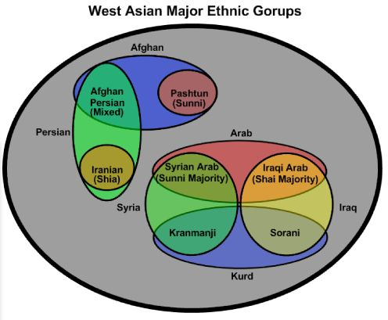West Asia (Middle East, Iran, and Afghanistan)

Stretching from the Mediterranean in the West to roughly the Indus river in the East, West Asia encompasses the Middle East along with countries like Iran, Afghanistan, and Pakistan. Though this region is the birthplace of Christianity, almost all countries in the region are now strongly Muslim, with only small pockets of

traditional Jewish, Christian, or other religious minorities. Even though this area has seen an increase in conversions to Christianity, the flight of traditionally Christian ethnic groups from the region means that the region is more Muslim in percentage than it has ever been.

Though the cultures in West Asia are many and varied, they do share some common traits, like strong Muslim heritage, that mean they can be treated as one large affinity cluster with several subgroups.

**Iran**

The Iranian revolution in 1978/9 ushered in a period of rapid and forced Islamization under the Ayatollah, who claimed to be both the Supreme Leader of Iran and of Shia Islam. Under his regime human rights were swept aside and the nation became a police state. Though the Iranian government is strongly Islamic, most of the people have more secular (even pro-Western) values. In recent years there has been increasing public unrest concerning Islamization and government control, and many Iranians have either worked against the government or fled to other countries.

Iranians are very proud of their Persian heritage, and in response to the hardline-Islamic government, many have even returned to the pre-Islamic Zoroastrian religion. Most of the Iranians who have come to Moria are proud of being Iranian and Persian, but not proud of their government. The national language of Iran is Farsi, which may also be called Persian.

**Afghanistan**

The North of Afghanistan is made up of a collection of many tribes, which predominantly use Farsi for inter-tribal communication. North Afghanistan has traditional Persian heritage but is distinct in many ways from the Persians of Iran.

The South is dominated by the Pashtun tribe(s), which are the ethnic base for the Taliban government and militias. The Pashtuns form the largest ethnic group in Afghanistan, and their brand of conservative Islam and social conduct (Pashtunwali) holds major sway over national culture. Pashtuns speak Pashto.

Many other small tribes and languages exist in Afghanistan, but they will likely fit into one of these two affinity clusters. Most people from Afghanistan speak Dari, a dialect of Persian which is generally mutually intelligible with Farsi. For this reason, many Afghans will say they speak Farsi, because it is a more broadly recognized language.

**Syria and Iraq**

At the time of writing (March 2018) about half of the people in Moria come from either Syria or Iraq, which form the Gulf/Levantine region in the Middle East. This means that unlike Afghanistan or Africa, the all ethnic tension is displayed on a far greater scale. There are two major distinctions which are necessary to understand these ethnic relations in camp. The first is the Syrian/Iraqi distinction, the second is the Kurdish/Arab distinction.

Both Syria and Iraq are Muslim majority, Arab majority nations with interrelated civil wars, but they nevertheless remain quite distinct. Prior to the Syrian Civil War, Syria was ruled by Bashar Al-Assad, a Shia dictator and autocrat who trampled on human rights but kept a stable country. Prior to the American Invasion of Iraq in 2003, Iraq was likewise ruled by Saddam Hussein, a dictator and autocrat who trampled on human rights but kept a stable country, only this time he was Sunni.

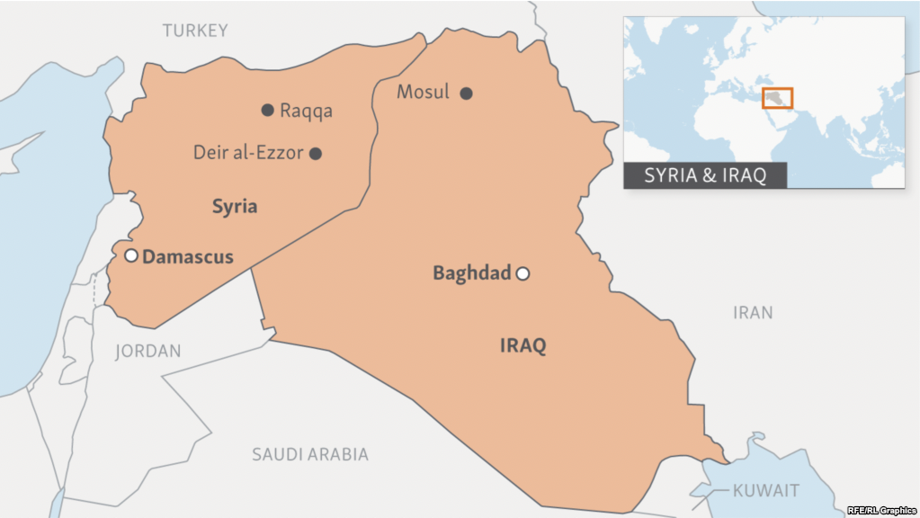Syria is majority Sunni  
Muslim and Iraq is  
majority Shia Muslim  
meaning both cases, a  
minority dictator ruled  
the country. In many  
ways this worked out  
quite well, because  
even though they were often brutal, they still had to try and keep national unity by working with the majority group. Their removal has caused a power vacuum leading to the bloody civil-wars we now see today.

Until 2011 and the Arab Spring, Syria’s economy was growing at an impressive rate, and the people of Syria had more doctorates per capita than the US. Many of the people in Syria were looking forward to a modern, advanced nation, and hoped the revolution would bring them closer to their ideal of a liberalized democracy, albeit with a strongly Muslim culture. Iraq has seen decades of war, serving as an unfortunate proxy in wars between global and regional powers. Though the nation could become an economic powerhouse due to its oil reserves, this has never been developed, and will not be so long as there are continual wars in the region.

Traditionally, Syria has been tied closely to Mediterranean culture and the Levant, whereas Iraq deals with more Persian influences like Iran and other Gulf nations. In addition to centuries of cultural factors, the Syrian and Iraqi dialects of Arabic are different enough that speakers may have difficulty understanding one another, and may be prejudiced when they hear another persons’ accent.

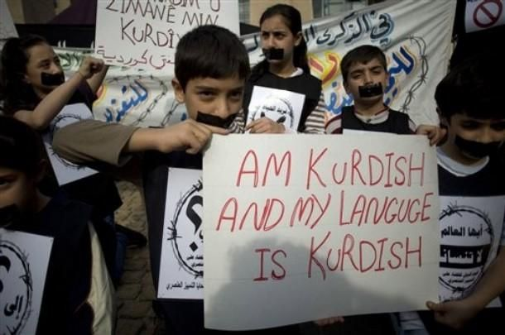**Kurds v. Arabs**

One of the sharpest sources of conflict is that between Kurds and Arabs, or really Kurds and all others. The Kurdish people are native to Kurdistan, a large swath of territory stretching from Northern Syria and Iraq into Iran, and also including sections of Southeastern Turkey. The Kurds are the largest group of people not to have their own nation. Among the many Kurdish sub-tribes, two are by far the largest. The Kramanji are primarily from Syria, while the Sorani mainly live in Iraq and Iran. Each Kurdish tribe has its own dialect of Kurdish, and very often Sorani and Kramanji cannot understand each other.

Historically the Kurdish people used to be culturally related to the Persians and Central Asians, and practiced Zoroastrianism prior to the emergence of Islam. The Kurds were converted to Islam in the middle ages, but have resisted the Arabization which it brought. Down through the centuries Kurds, Arabs, Turks, and Persians have engaged in war, and Kurds have long desired to have autonomous rule under an independent Kurdistan, fighting to this end. For this reason, Kurds have been heavily persecuted, especially in Iraq and Turkey, where they are often seen as terrorists because of their support for violent breakaway groups. Kurds in Syria (Kramanji) generally enjoy better relations with Arabs than do Kurds in other countries, but even this has deteriorated during the Civil War.

**Arab North Africa**

The last group to be included is Arab North Africa. In the 7th and 8th centuries, the Arab conquest conquered most of Northern Africa and the Sahara, and now the countries of Egypt, Libya, Tunisia, Algeria, and Morocco use Arabic as their major national language, and a majority of the population identifies as Arab. It should be noted that the cultures of North Africa differ from the traditional Middle East in several ways. First, from a linguistic point of view, the Arabic spoken in much of this region (Maghrebiyah Arabic) is the most unique of major Arabic Dialects, and is a formidable barrier to communication. Second, the culture of North Africa is a mix of Arab culture and that of pre-Islamic ethnicities, such as the Yamizagh (Berber) people, and traditional Egyptian culture. Third, the reasons that POC’s from North Africa come to Greece tends to be different than that of Syrians and Iraqis. With the exception of the unrest in Libya, there are no large-scale conflicts in North Africa, and many people who are leaving these countries are not directly fleeing war but may have been caught up in or be the victims of organized crime and even terrorist organizations.

West Asian Culture and Customs

Honour and Shame

Honour and respect are major driving forces in West Asian Culture. The premise of the honour/shame paradigm is that a person tries to limit their actions to those which are seen to be honourable in their community, and which will not hurt their standing in the unwritten honour codes of their culture.

The comparison has often been made that whereas in the Western world (Europe and North America) we work in a legal system of innocence and guilt which is determined by clearly codified laws, people from the East tend to work with an unwritten group consensus which dictates which actions are honourable and which are shameful. The emphasis is shifted from being judged as innocent/guilty according to a legal procedure to being judged by the community to be an honourable or dishonourable person. In the same way that in the West people can sometimes do evil things and still be considered innocent because their actions weren’t technically against the law, in the East, people can sometime do evil things but still be seen as honourable if they maintain the respect of their group.

Both Westerners and Easterners definitely have an understanding of both honour/shame and guilt/innocence, and it is a mistake to see them as entirely separate paradigms. Still, Westerners will have to work to understand the importance honour in West Asian cultures, because in those cultures it exerts force far greater than in the West. What exactly it means to maintain honour differs between cultures, and is determined by many factors. Below are several topics of West Asian culture which help determine someone’s honour/shame status.

**Working in the Honour/Shame Paradigm**

It is important that volunteers understand that in West Asian cultures, honour is a reciprocal value, expressed in the Arabic expression “eHterom tehterom” which essentially means that “honourable people honour people.” The converse is that only dishonourable people needlessly dishonour other people.

Often when volunteers work in Moria, they think that it will be easy to “shame” someone into doing something that needs to be done. In practice this is rarely effective even for the short term, and in the long term has the potential to ruin relationships. While there are times to call someone out on sin, shaming people should never become a tactic we just play with to meet our goals. As Christians we are told to care for those who curse us, abuse us, and persecute us, and if ever we begin to enjoy “playing the shame game” we are demonstrating that our own hearts are not right before God. Before you engage in something which will negatively affect someone else’s reputation, pause to check your motives. Pray for the person who is angering you; do not be overcome by evil, but overcome evil with good.

So how should people work positively within the honour/shame paradigm? The key word is respect. Remember that honourable people honour people. When refugees see that you honour and respect them they will be inclined to reciprocate that, even if they do not want to, because their culture dictates that they must act honourably to people who honour people, or else they are being the dishonourable ones. Even taking time occasionally to calmly ask for someone’s respect may do wonders to return an otherwise unruly conversation to civility.

Honour people; they are made in the image of God.

Here are a few practical tips for how to demonstrate respect for people:

* Ask their name
* Shake their hand
* Make eye contact (be careful with this cross-gender)
* Speak calmly
* Ask people how they are before you start a conversation
* Try to speak as much of their language as possible

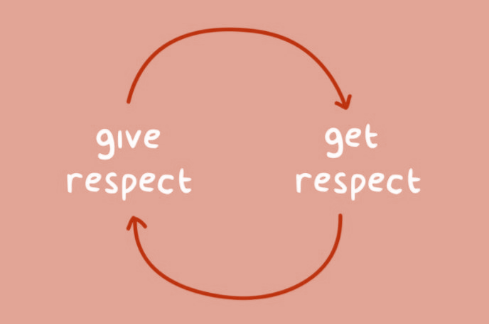Take time to explain the reason why seemingly arbitrary rules and restrictions are in place.

Don’t make accusations lightly

Don’t flaunt power; if you need something done, come from a position of humility. People are likely to do something for you if you ask them for help that they would not have done if you demanded it of them forcibly.

Appeal to people’s kindness and personal responsibility

Hospitality

Hospitality is a cultural value shared by much of the West Asian world; it is something they are rightly proud of. Many volunteers have been struck by how refugees welcome them into their tents for tea and food, even given the unenviable position in which the refugees find themselves. In West Asian cultures, guests are meant to be served food and honoured, and it is rude to turn someone away from your

house without offering them something to eat or drink. In many ways this stems from the honour shame principles, because it is honourable to be able to provide for guests and strangers, and it is honourable to honour other people.

Here are some tips for how to receive (and give!) hospitality with West Asians

* 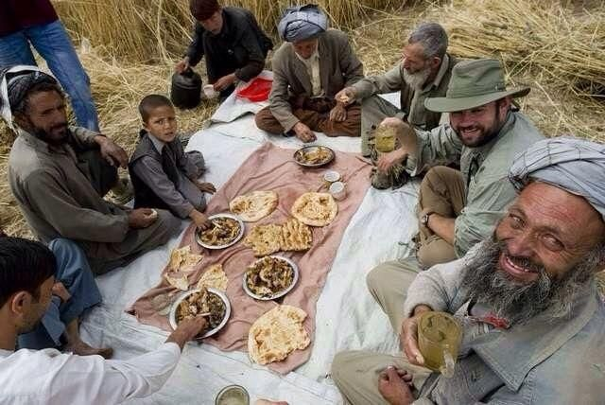Don’t feel bad  
  about accepting invitations to eat or drink with refugees. This is a great chance for them to feel that they are at home, and for once to be able to give something rather than continually begging/receiving. It helps give dignity.
* Unless you have an allergy, if food is served to you, eat it.
* Refugees will understand if you need to work and do not have time to eat. If you are invited to eat but cannot, just explain the situation, thank them, and move on.
* Different cultures have different expectations on how you eat, whether you should eat everything on the plate (to show you enjoy it) or whether to leave something (to show you are full and have been well served). Ask a trusted refugee friend for more cultural insight when necessary.
* When giving hospitality, you will be expected to take a more active role. Don’t just say

“there’s food if you want it” offer it to them, get water/tea for them, for us that may seem like fussing over someone, but that is good hospitality in West Asia.

Group Unity

In West Asia, people know who they are largely based on their status in their home society. They have status because they came from a particular family, or were well honoured back home for any number of reasons. Because of this, the honour of an individual is closely related to the honour of the group, and vice versa. The actions of one person reflect poorly on the whole group, and the reputation of the group may be conferred to an individual. This is why the shaming of one person is seen as an attack against the whole. This forms the basis for honour killings in West Asia, because honour killings demonstrate just how seriously the group takes any actions (like adultery, conversion to Christianity, etc.) which reflect negatively on the whole group. On the other hand, it can be the basis for extreme acts of kindness as people try to help their family or friends in difficult situations. West Asians tend to place great emphasis on how their actions will affect their group as a whole.

Just as with other cultural matters, the issue of group unity and cohesion has been thrown into a state of flux. Those who arrive in camp (especially single men) arrive with little family support, and are more free to seek their personal interests. Because of the social change in the Middle East, and because the refugees are essentially seeking to start a new life in Europe, they don’t have the same allegiances to traditional values that many people back home do. Actions which would bring shame on their family if they committed them back home are fair game, because nobody back home has to know what people are doing in Europe.

Gender and Modesty

Though exact cultural customs vary tribe to tribe, the interaction between genders in West Asian countries is far more limited than in West. It is difficult to determine the extent to which this is due more to specifically to Islam or West Asian culture in general, and is probably seen as an interaction between the two.

In most of West Asia, streets and public restaurants belong to men, whereas the homes belong to women. Men from West Asia generally go to work during the day, and before coming home in the evening may spend several hours at a cafe with other male friends, while women stay at home may spend free time visiting their friends in each other’s homes. This often plays out in camp in that women may remain in their tents most of the day while men are expected to do work that needs to be done outside of their tent.

Islam places a great deal of emphasis on modesty, and while the exact modesty standard is different country to country, certain practices (like wearing the hijab) are almost universally practiced because they are commanded in the Quran. Christianity too teaches modesty, but does not specify the exact ways that this should be expressed cross-culturally as much as Islam does. Because we realize that there is a cultural dynamic in modesty standard, we need to be particularly sensitive to the expectations and understanding of West Asians.

* In West Asian culture, these are the general standards of modesty
* Women should not show their hair
* Women should cover their arms to their wrists
* Women should cover their legs to their ankles
* Women should not wear tight fitting shirts or trousers, or often must wear dresses over their trousers

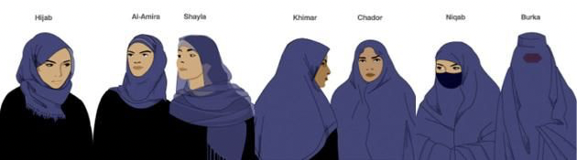

These are the female modesty standards in a mixed gender setting. When only women are present, West Asian women are relaxed and may dress in modern Western clothing. In application, not everyone follows these standards. Kurds are much more liberal than Arabs, Northern Afghans are more liberal than Pashtuns, and so on. Additionally, because refugees are in a state of cultural flux and don’t have their traditional clothing with them, they are forced to “make do” with what they have in Europe, even if they are uncomfortable with it.

Where these issues become problematic is in the realm of cross gender relationship, because West Asians and Westerners have very different sets of expectations as to how such interaction should take place. Much of this has been discussed already in the section of rules, so there is no need to reiterate it here. What is important to remember is that no matter how good a job we do of carefully keeping boundaries in cross-gender relationships, we have already broken them many times from the West Asian point of view. As Christians we are called to “give thought to do what is honourable in the sight of all people,” and for us that means living within boundaries that we ourselves did not set and often feel uncomfortable to us.

**Additional Notes and Taboos**

* Be careful about the direction that the soles of your feet point, and try not to point them at people when you prop your legs up.
* To many people from the Middle East the left hand is considered dirty. If possible try to only eat, shake hands, motion people, or give things to people with your right hand. Doing so with your left hand may seem uncouth or sometimes even rude.
* Respect food (especially bread). Muslims tend to emphasize the fact that food is a precious gift from God more than Western Christians, and so throwing food away or setting it on the ground is seen as disrespectful to God.
* When in Church, treat the Bible with respect, do not set it down by your feet or fold its pages back. This comes across as extremely disrespectful to most Muslims, who then assume that Christians do not hold God’s Word in esteem.
* If you are a man and must talk with a woman in her tent, remain outside unless her husband is inside. If she does not have her hair covered when you arrive, give her time to cover before speaking with her.
* When entering someone’s tent, remove your shoes.
* When starting a conversation, first ask people’s name and shake their hand. This is doubly important if there is the possibility that the situation will turn confrontational.

The Syrian Civil war (2011-Spring 2018)

Because a large group of refugees coming through Moria are coming from Syria, and are refugees due to the Syrian Civil War, and current events in Syria and Iraq still affect those in camp, it may be useful for volunteers in Moria to get a little bit of background information about the war. Below is a brief history of the Syrian Civil War.

**Pre-2011: Peace in Oppression**

For thousands of years, Syria’s population has been religiously and culturally diverse, encompassing large minorities of Christians, Kurds, and other small ethnicities. Prior to the Arab Spring, the nation of Syria was modernizing under the totalitarian rule of the semi-secular Shi’ite Bashar Al-Assad. Given that Shi’ites are a minority in the majority Sunni nation of Syria, Assad held onto power by offering relative protection to other minorities, and maintaining close control of the Sunni majority. Syria was a brutal police state which did not tolerate dissidents, but for the most part the nation was economically progressing under his regime.

**2011 to Summer 2014: Syria Crumbles**

All this changed in the Spring of 2011, when popular uprisings all over the Middle East began to topple other dictatorial regimes. The people of Syria hoped they could add to the (few) success stories of the Arab spring and trade their current government for a truly democratic one. Assad responded with violent force, massacring demonstrators and torturing innocent people. In turn, protests became more violent, and as soldiers defected from the Syrian military, the conflict unfolded into full scale civil war. The country splintered into dozens of rivaling fiefdoms controlled by local warlords who often received funding from foreign powers. Iran (a fellow Shi’ite nation) poured money into propping up the Assad regime, and Shi’ite Hezbollah entered the fray to gain access to the border with Israel, while Al-Qaeda and Sunni parties supported rebel group, each with their different vision of what would become of Syria when the fighting stopped. During this period Assad first began to use chemical weapons against his own people, and although this was condemned by the US and other Western powers, few people wanted to send soldiers into the Middle East to stop him.

The Syrian Civil War seemed to have come to more or less a deadly standstill in 2013, with continual fighting wearing down resources almost as soon as foreign donors could supply them. The effect was the total destruction of large swaths of Syria, entire cities being reduced to rubble, and the beginnings of the European Refugee Crisis.

**Summer 2014-Spring 2017: The Rise and Fall of ISIS**

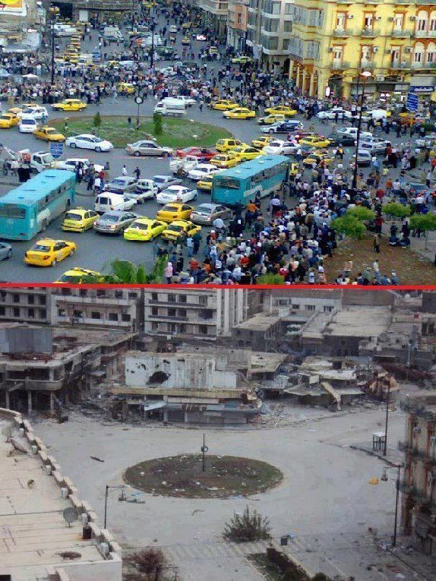The fighting entered the next phase with the rise of ISIS  
(Islamic State of Iraq and Syria), an Al-Qaeda splinter  
group, which swept through much of Northern Syria and  
Central Iraq, gaining control of cities at an  
unprecedented rate, and ultimately taking the Syrian  
city of Raqqa to be their capital. Wherever they went  
they enforced a brutal form of Islamic Sharia law. ISIS  
practiced the mass killing of Christians, Kurds, Shi’ites,  
and Yazidis. Pressure mounted for the US and other  
nations to intervene, and both Russia and the US increased military involvement.  
During this time, the Kurdish people emerged as one of the most formidable fighting forces, and the US gave them military support in their highly effective campaigns against ISIS. By early 2017, the tides turned against the spread of ISIS, and their defeat seemed imminent.

**Mid 2017-Spring 2018: International Proxy Wars**

Though ISIS continues to hold some small pockets of territory, the have been reduced to a very small fighting force, and their only safe havens now lay outside the Middle East proper. In Iraq, the Kurdish military still control more land than they did before ISIS arose, and now share a surprising level of respect from Iraqi national leaders. In Syria, the story is different, and the fighting has entered another dangerous phase. With the help of Russia, Assad now holds most of Syria, and is pressing the attack into the remaining rebel territory. The war has been complicated by the invasion of Syrian Kurdistan by Turkey, who is unwilling to see a semi-autonomous Kurdish nation arise on their border, fearing that it would embolden Turkish Kurds to rise up. Assad has stood by as Turkey has invaded and destroyed Syrian Kurdish cities like Afrin. Additionally, a proxy war between Iran and Israel has begun, with Iran supporting Hezbollah in Syria, sending drones into Israel. Recently, an Israeli fighter was shot down over Syria, and Russian forced clashed directly with American soldiers in Syria. The war now includes several conflicts, a potential US-Russia-Assad conflict, a Turk-Kurd conflict, and a Israel-Iran-Assad. Seven years after the Syrian Civil War started, peace seems as impossible as ever, and the possibility that a major international conflict will break out in the region is becoming more and more likely.

Islam and Christianity

In Islam there are six core beliefs that one must hold to make one a Muslim. Islam teaches that all prophets (including Jesus) taught these six beliefs, and they are the core of Islamic theology. In addition, there are five “pillars” which muslims must perform, and these form the practical side of Islam. Whereas the beliefs make someone a Muslim, the pillars make someone a ​*good* Muslim.

The Six Core Beliefs

**God:** Islam’s conception of God is simple. He is the creator and sustainer of the universe, merciful and just, and the only one worthy of worship. Central to Muslim teaching is the doctrine of God’s “oneness” (Arabic ​*Tawhid*)​ which means He cannot be complex, and as such rules out any Trinitarian conception.

**Angels:** To Muslims, Angels are a very present reality, either as a good force, or as an evil force in the demonic ​*jinn*.​ Muslims believe both to be far more active than most Christians do.  
**Prophets:** The concept of prophethood is important in Islam, just as it is in Judaism and Christianity, and most Biblical figures are also prophets within Islam. Except for a few small sects, Muslims believe that all prophecy ended with Muhammad.

**Books:** Though Muslims believe many prophets have come to earth, there are four main books they hold as coming from God and as having some level of authority today. The Tawra’ (the book of Moses) the Zabour (The Psalms) the Injil (the Gospels), and the Qur’an. Muslims believe that the first three books have been corrupted, and only the Qur’an has remained “pure.” **Determinism:** This notion of determinism is best expressed in the Muslim expression “Inshallah” which often signifies a fatalistic resignation to one’s lot in life as being from God, and expressing powerlessness to change it.

**The Day of Judgement:** Muslims believe that when they day they will be judged based on their personal merit, and reap the rewards of their actions on earth. Muslims do not believe they can know what will happen to them on judgement day, there is no assurance of salvation at all.

The Five Pillars of Islam

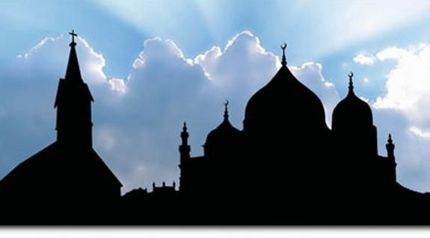**Charity:**​​ This is in many ways comparable to the Christian tithe, just valued and weighted differently because it is not based on income but on net worth.

**Pilgrimage:** Every Muslim man who has the financial means is required to travel to Mecca once for the annual Hajj pilgrimage. It is said that when someone goes on pilgrimage to Hajj, all sins prior to the pilgrimage are forgiven.

**Prayer:** Muslims are commanded to pray towards Mecca five times daily. To most Muslims, and according to some traditions to Muhammad himself, this is the most important pillar of Islam, and the primary expression of a Muslim’s devotion.

**Fasting:** The month of Ramadan is the 30-day period of Muslim fasting. During Ramadan, almost all Muslims are supposed to refrain from food or drink during everyday from sunrise to sunset. **The**

**Creed:** The creed, or ​*shahada* meaning testimony, may be the most important of the six beliefs or five pillars of Islam. It reads “there is no god but God, and Muhammad is the prophet of God.” Saying this creed honestly three times is the way someone is said to convert to Islam, and in many cases refusing to say the shahada has cost a former muslim his life.

Practical Notes and Applications

Over the past 1500 years, there have been many misunderstandings that have developed between Muslims and Christians and in our conversations with Muslims, we risk accidently reinforcing them. For example, Muslims are often taught that when Christians talk about Jesus as the Son of God, what we mean is that God had a physical relationship with Mary to create a sort of demi-god Jesus. Clearly this is not what we mean, but unless we carefully explain what we really mean, every time a Muslim hears the phrase “Son of God” it reinforces a horrible misunderstanding. This is just one example of how the terminology we use daily, even without a clear idea of what exactly we mean, has the potential to push Muslims away from interest in Jesus. Part of loving Muslims is learning about them, and learning how to carefully explain our beliefs in a way that increase understanding rather than reinforce misunderstanding. Make sure that you do not speak in “Christianese” when talking with Muslims, or use terms without knowing what they mean.

Muslims place a high value on formal expressions of honour and respect. When they come into a Church and see Bibles placed on the ground or set by someone’s feet instead of on an elevated, honoured place, they assume that Christians hold the Word of God in little respect. The same goes for the way that Christians pray and talk about God. Muslims are often off put by the directness with which Christians pray, making demands of God, or the way that they speak informally about “talking with God” as if He were just a friend. Muslims can come away with the idea that Christians think of God flippantly.

Asylum procedure

To understand the situation that refugees on this island are facing currently, you need to understand some of the history surrounding the the Turkey-deal. RefuComm has made an explainatory video which gives some of this background information, and explains some of the asylum procedure: ​https://www.facebook.com/refucomm/videos/579317675753372/

Turkey-deal

Before March 2016 (Turkey deal) people only stayed for a short time on the Greek islands, and after being processed could travel freely to other countries in northern Europe. Over a million people crossed the straits between Turkey and Greece’s eastern Aegean islands. Around the same time when the Turkey deal with the EU was made, countries closed their borders. That meant the end of the Balkan migration route.

Under the Turkey deal, Turkey has agreed to take back any asylum seekers who land in Greece. Migrants in Greece are now expected to be sent back to Turkey if they do not apply for asylum or their claim is rejected. In exchange, Turkey would receive €6 billion to assist the vast refugee community hosted in the country, Turkish nationals would be granted visa-free travel to Europe and, once the number of irregular arrivals dropped, a “voluntary” humanitarian scheme to transfer Syrians from Turkey to other European countries would be activated.

All asylum applications had to be assessed in Greece now. People have to wait months for their interviews now, while camps on the islands are getting fuller.

Since the EU-Turkey agreement, refugees have to show in an admissibility check that Turkey is not a safe country for them. If they are declared inadmissible for the asylum interview they will be sent back to Turkey. Therefore, even refugees with well-founded asylum claims are returned to Turkey

On March 19, 2016, Turkey and the EU signed “the Accord”, which was put in place to stem the flow of refugees attempting to cross the Aegean Sea from Turkey to Greece, and thus enter into the EU. Before March 19, those arriving on the boats were granted refugee status, and after a brief processing, were given a paper that allowed them 60 days in Greece, either to move on or apply for Greek refugee status. After midnight of March 19/20, all those who arrived in Greek waters were no longer automatically considered refugees, but rather all were interned for illegal entry. They were given 5 days to apply for Greek asylum, or be forcibly returned to Turkey.

As part of the accord, both Turkey and the EU agreed to certain requirements and pay offs.

* The EU agreed to pay Turkey 3 Billion Euro. This money was to help Turkey control the

borders, as well as house and feed the refugees in their country.

* For every Syrian that was returned to Turkey after March 20, another Syrian would be

repatriated to Europe.

* Turkey would work towards liberalizing their laws, in accordance with EU standards, and

in return the EU will drop visa requirements for Turkish citizens wishing to visit the EU.

* Irregular migrants may be held in closed reception centers on the Greek islands, subject to EU legislation – in particular the ​EU Return Directive​. Asylum seekers will be accommodated in open reception centers on the Greek islands.

In practice, this has failed in many ways. There have been numerous court cases brought against the EU questioning the legality of the accord. In reality, although there have been many refugees returned to Turkey, and many Syrians sent on by Turkey to Europe, those refugees returned to Turkey have NOT been Syrians, as per the accord. The coup attempt in July of 2016 has caused Turkey to impose martial law, thus negating many of the moves toward liberalization of their laws, such as freedom of expression, speech and religion. Furthermore, by the EU’s own admission, implementation of the accord will take 4,000 workers, including border guards, asylum experts and interpreters. Perhaps half that number are actually working in Greece on the accord. Finally, a strict reading of the housing clause has meant that until the refugees are given an official designation (refugee vs. migrant, asylum accepted, etc.) they are not allowed to continue on to the mainland, thus overcrowding the island hot spots.

The accord has significantly slowed down the numbers of new arrivals on the islands of Greece, and thus also reduced the numbers of drowning in the Aegean Sea. Unfortunately, it has caused a sharp rise in attempts to cross from Libya into Italy, a far more dangerous crossing. By June, 2017 there had already been a reported 2000 deaths at sea in between Libya and Italy.

For the official EU press release on the agreement, see: http://europa.eu/rapid/press-release_MEMO-16-963_en.htm

Asylum procedure

After people arrived on the island (they all arrive illegally by boat from Turkey) there is a lot that is unclear about the procedure in Greece. There are people who do not know that their application for asylum only affects Greece and no preferred country can be specified. In addition, there are also many rumours about the procedure. There are unaccompanied minors who lie about their age, because they have to stay on the island until they are 18 years old. If they subsequently apply for a reunion with family members in the EU, it is difficult to recover and to try to change the age and can only be done with the help of lawyers (some of whom work voluntarily in the camp).

Following information has been found on the website ​www.refucomm.com

Upon arrival on the island people get their first short interview (by Frontex), mainly to gather information about smugglers, their routes and networks. After that, people are transported to a Reception and Identification Center, also known as a 'Hotspot' in order to verify and register their identity and identity asylum procedures in Greece.  
First, people will be subjected to "nationality screening" and fingerprinting to their identity and first point of entry into the EU in the Eurodac database.

The next step is the 'reception and identification procedure' by the Reception and Identification Service.

Following the deal between the EU and Turkey, new procedures have been designed for situations where there are large numbers of refugee arrivals to help the authorities:

1. Identify and return those who do not claim asylum
2. Examine whether people should be readmitted to Turkey if they would have sufficient protection there.
3. Decide whether a person’s asylum claim will be heard in Greece under the regular, border, fast track, accelerated or Dublin procedure.

People will be given a date for registration with the Greek Asylum Service where they will finally lodge their claim for asylum. This registration appointment is the beginning of the formal procedures of claiming asylum or starting the family reunification process if they are eligible. At this appointment they will be given a registration card (‘Ausweis’).

After registration, everyone will eventually have a personal interview, but the type of interview depends on: • the country of origin • what their legal status was in Turkey or elsewhere • whether they have close family elsewhere in Europe • whether they may be classed as vulnerable.

If people are not classed as vulnerable and are not eligible for family reunification to another EU member state they will undergo an interview to be assessed for international protection in Greece. At registration, the Greek Authorities use European asylum recognition rates, to decide which type of interview they will have. This depends on whether they decide that they come from a country where they are at a high risk of war or persecution or whether they come from a country that is at low risk.

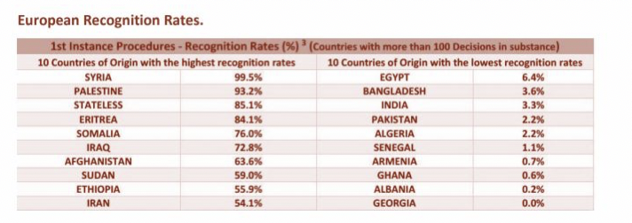

So, as you can see from figures on the left of the chart, a high percentage of people who come from Syria, Palestine, Stateless people, Somalia, Iraq, Afghanistan, Sudan, Ethiopia and Iran get asylum in Europe. These are nationalities with high recognition rates. On the right of the chart you can see that a low percentage of people are granted asylum in Europe from other countries. These are nationalities with low recognition rates. People with a ‘low’ recognition rate are subject to a different procedure to those with high recognition rates.

If people get a negative decision on admissibility or eligibility they can appeal (within 5 days).  
In general, people are required to stay on the Island and to not leave the island without special permission. If they do go to the mainland they will be considered to be there ‘illegally’ and they will not be able to register on the mainland which means they will not have access to the asylum, relocation or reunification processes or access to health, education or cash benefits and they could be arrested and returned to the Island. However, special permission may be granted to some people for various reasons, for example, vulnerable cases, unaccompanied minors moving to mainland accommodation, people given special leave to attend interviews or hospitals on the mainland, eligible family reunification under Dublin III cases.

