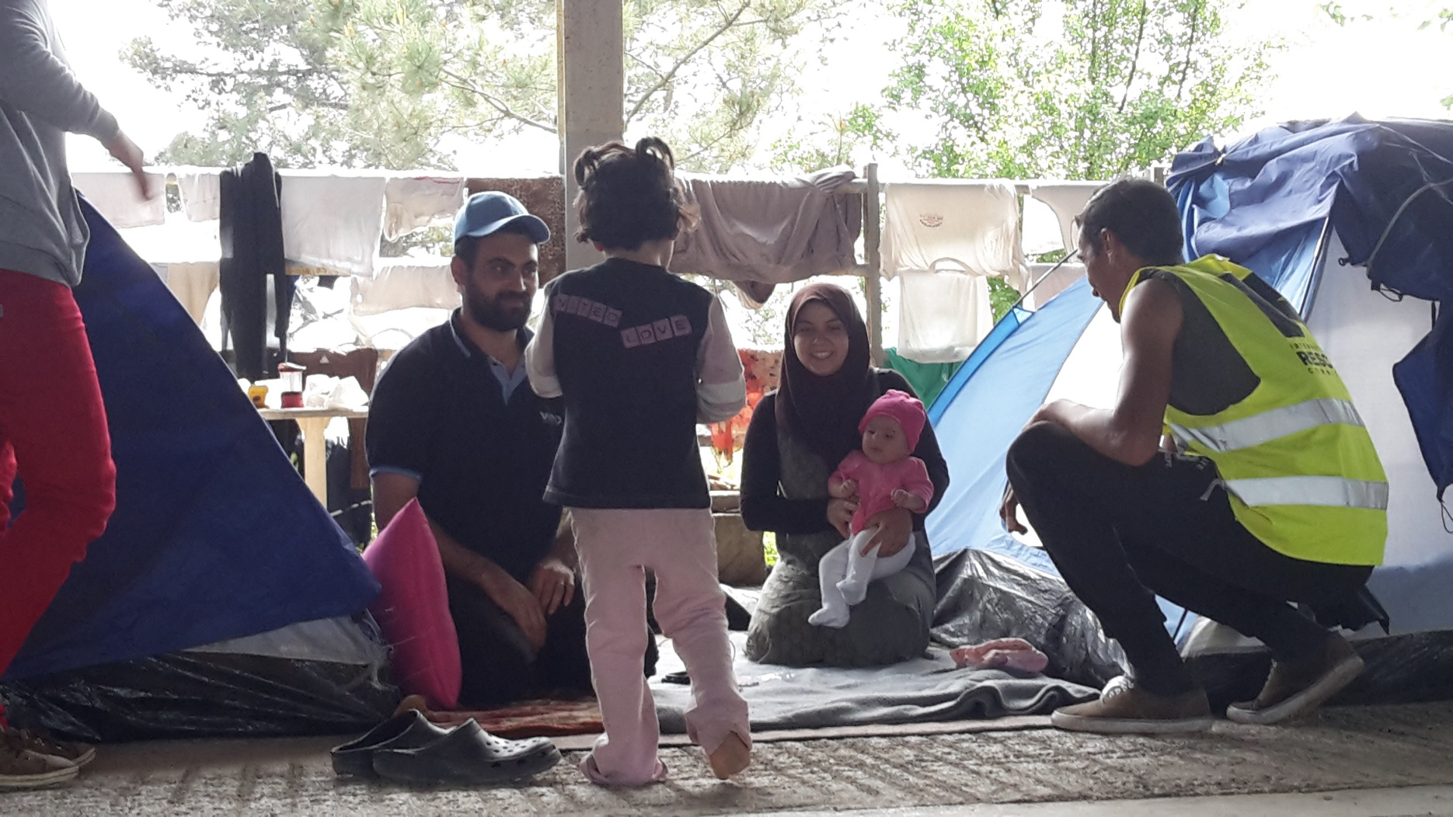

GREECE HUMANITARIAN
PROJECT HANDBOOK

2020

Table of Contents

Welcome 3
Project Partner 6
Country Background 7
Important Information 8
Before You Depart 9
Packing List 10
While on Project in Greece 12
Sharing Stories 14

Appendix 1 : Staying Healthy 16
Appendix 2: Legal Project Details 17
Appendix 3: Contacts and Telephone Numbers 19

Welcome to our humanitarian project to Greece!

Thank you for your willingness to join us in working with local staff and volunteers to help bring hope to families living as refugees in Greece.

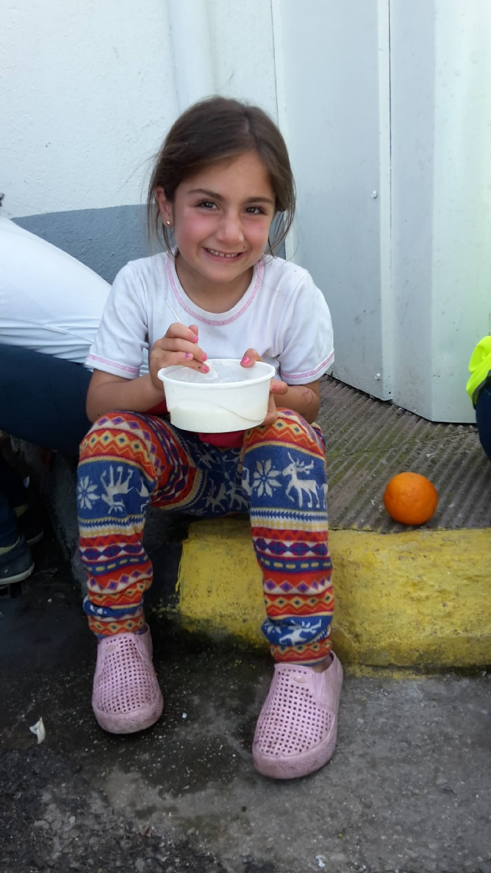
At the heart of GAiN is a desire to bring tangible help to those people facing situations of crisis and poverty. By being part of this team you are part of the network of people involved to in helping to restore hope and dignity to those on the margins.

GAiN UK is part of a worldwide network of offices from eleven different countries that respond in times of disaster and provide ongoing support in development. Collectively, we are involved in over 50 projects worldwide and the impact we can have when we work together is much greater than on our own.

By involving students, families, professionals, community groups and churches, GAiN UK is seeking to turn the simple actions of donating a blanket, committing to sponsor a child or going the extra mile as you are and being on the ground in a project location into bringing practical long-term change.

Seeing change in situations like this doesn’t happen overnight. We realize it can be a long journey but we also have a part to play. It is truly a great encouragement that volunteers from all over Europe can get involved in making a difference.

This handbook will provide some details about your upcoming trip as well as answer any questions you may have. Please read it carefully, as it will help you properly prepare for the trip, as well as the circumstances you will encounter.

We see it as a blessing that we get the chance to help in a variety of ways. Offering a slight relief for a refugee; a happy day for a child or the support people tirelessly to ensure that there is enough food, safety and support in every camp.

We wish you a good preparation time and a very blessed journey!
GAiN Project Team, GAiN UK

Humanitarian Relief Project Partner: Euro Relief

During our project we will have the opportunity to serve the families who have fled from violence and conflict in their countries to seek a place of safety. We will be involved in practical work and encouraging those people that we meet not to lose hope.

Our partner in Moria is EuroRelief, an NGO that has permission from the UNHCR to do a large part of the work in camp Moria. They work with long-term volunteers and groups of volunteers such as those from GAiN to carry out various activities. EuroRelief currently manages the accommodation of refugees, dormitories for men, support in the camp and a 'clothing store' in Moria, where refugees can choose their own clothes. GAiN Nederland, together with other GAiN offices worldwide, cooperates with EuroRelief in the form of sending relief goods and sending teams of volunteers to Lesvos.

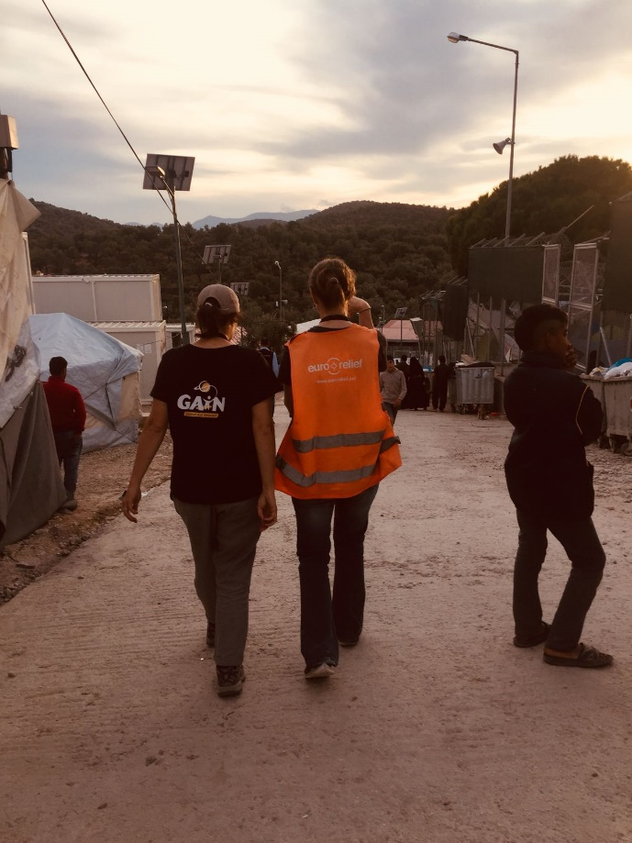
The majority our time will be spent working in and for camp Moria. After arriving at Lesvos, our first day will start with an introduction-meeting in Moria, learning about the camp, the situation, duties and rules, in preparation for the work that will be done. All volunteers are divided by EuroRelief into three shifts: 8:00 – 17:00, 16:00 - 24:30, and 24:00 – 9:00.

We try to indicate preferences for our group to the coordinators, but the schedules are made based on the needs of the camp and no guarantees can be given regarding this. Activities during the day may include: sorting and handing out clothing, food distribution, waste disposal, cleaning toilet facilities and guarding the gates of various 'neighbourhoods' within the camp. Slightly depending on the composition of the group, as GAiN we aim to provide and prepare some ‘fun’ activities for kids, youth or women.

Your stay at Lesvos is the chance to communicate with refugees and build relationships with them; please make the most of this opportunity to meet people and look at the world through their eyes. Listen to their stories, emphasise with them and try to understand the nature of the crisis.

Please note that as with any humanitarian project we seek to serve the current needs of the people on the ground and so our plans can change from day to day according to the current situation. This will require us to approach our time with flexibility and being ready to adapt to changing circumstances.

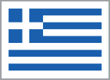
Lesvos, GREECE: Country Background

Greece has one of the longest histories of any country, and is considered the cradle of Western civilization, and as such, is the birthplace of democracy and Western philosophy. The Greek islands are well known as a tourist destination mainly because of the clear blue colour of the water, the white beaches and a beautiful underwater world. Furthermore, Greece is known for its versatile kitchen with mostly meat and fish dishes.

Lesvos (Lesvos) is an island in the Aegean Sea and part of the North Aegean Islands, which forms a region of Greece. The capital of Lesvos is Mytilene (Mytilene). For tourists there are many facilities, such as a good road network, tourist towns, shops, hotels and restaurants. The island is mountainous with mostly dense vegetation. Many tourists come for hiking in the beautiful rugged nature reserves and the beautiful coast. There are several wide sandy beaches for the enthusiast. Furthermore, the island is still known for its hot springs, many monasteries and the great diversity of bird species.

Lesvos is a Mediterranean climate. In the winter months the temperatures are around 10-15 degrees and in the summer months around 25-30 degrees.

Fact File:
- In Greece the Euro (EUR) is the national currency.
- There is two hours’ time difference between Greece and the UK
- Electric sockets use two pin plus (round pins)
- The dial code for phoning Greece is 0030 or +30.
- Alcohol and tabacoo can be bought from 18 years of age
- Smoking is banded in public areas

Did you know..
.. Greece has another alfabet?
.. Greece was once part of Turkey and has been independent since 1832?
.. It is compulsory for anyone above 18 to vote in Greece?
.. Greece has more than 250 days of sunshine per year?
.. Greece has the most archaeological museums in the world?
.. The Olympic Games originated in Greece?

Emergency numbers

Emergency: 112
Police: 100
Tourist police: 171
Fire department: 199
Ambulance: 166

IMPORTANT INFORMATION

Money

Your accommodation, meals, and in-country travel will all be covered during our stay in Greece. You may want to take additional money with you for your own personal spending or any souvenirs that you may wish to buy during our time off.

Also, please note that under no circumstances should you give out money to people that we meet. If you wish to support the project and/or individuals you should always talk to the GAiN project manager beforehand. He/she is in charge of financial matters concerning the project and will know how to use the donations best for the benefit of the project and the locals.

GAiN UK has funds available to purchase supplies for distribution to the families whilst we are in Greece. If you would like to raise additional funds to bring with you for this purpose that is also great as well. Another idea is to invite people in your community to collect items for the children that you can bring with you for the activities. Don’t forget to leave enough space in your bags!

Liability & Insurance

Please be aware of the fact that you take the trip at your own risk. GAiN and Agapé cannot be held responsible for accidents or other occurrences that may cause difficulties of any kind during your stay in Greece. As part of your booking, Agapé will take out travel and medical insurance for the duration of the project.

Flights

We will provide you with the in-country flight details once numbers are finalised and the flights are booked. The timings we give will be local and are subject to alteration by airlines.

When you receive your confirmed flight itinerary, please review your details carefully and please ensure the spelling of your name matches that on your passport.

BEFORE YOU DEPART FOR GREECE

Vaccinations
Before travelling to Greece, it is recommended to visit your local travel nurse or GP to confirm you are up to date with your vaccinations that are normally recommended for life in Britain. You should also get individual advice on any additional vaccines or medication that you should take for your trip to Greece.
You may wish to discuss with your travel nurse having a Hep. A vaccination as your team may be involved in toilet cleaning duties.
You should also share your travel plans with any doctors you are currently seeing for other medical reasons.
Please refer to Appendix 1: Staying Healthy during your Stay for more details.
If you become ill with a fever or flu-like illness after you return home, you should seek immediate medical attention and should tell the physician your travel history.

Visa and Entry Regulations

British passport holders do not need a visa to visit Greece for this project. Your passport should be valid for a minimum period of 6 months from the date of entry into the country.

If you hold a different passport it will be your responsibility to check on the requirements and, where necessary, obtain the necessary visa. Our projects coordinator will be able to help you obtain the necessary documents, however any additional costs will be your responsibility.

Please have the address of our accommodation in Thessaloniki on hand during travel in case this is needed for entry through passport control.

PACKING LIST

Please note we are flying with Aegean Airlines from Athens to Mytilene

Cabin Baggage Allowance:

One small cabin bag 8kg max. 56cm x 45cm x 25cm (including handles & wheels)
Plus one personal item that can fit under the seat in front, e.g. backpack or handbag.

NB: You small cabin bag may be placed in the hold so pack any items you need on the plane in a small bag/personal item.

We will be spending most of the time outdoors so please pack accordingly.

ESSENTIALS: Do not forget
- Passport
- Driving licence (for those we have asked to drive)
- Credit or debit card to use in Lesbos or EUR cash for personal spending
- Phone & charger
- Electrical adaptor (European, two round pin)
- Plastic box for packed lunch
- Sturdy water bottle
- Sunglasses

CLOTHING: Bring layers that are quick drying
- Trousers (comfortable to move around in, with zipped pockets are helpful)
- Mid-calf skirts can be worn with leggings or ankle length skirts/dresses
- Lightweight long-sleeved and short sleeved shirts/thick strapped tank tops for girls (dress modestly to be appropriate to dress code)
- Closed toed, sturdy shoes/trainers for being out in the camps (wear on the plane)
- Pair of shoes to wear when you are off duty
- Jumpers for the evenings
- Warm and Waterproof Coat
- Hat (sun hat or warm hat for the night time)
- Pajamas
- Underwear
- Casual Clothes for after our programme in the camp and free time

- There will be access to laundry facilities at the accommodation. We will purchase team washing powder once we arrive.

- Please travel with a minimal amount of jewelry/valuables, keeping in mind that everything you take with you children may like to play with and we also want to be sensitive to the situation we are entering.

TOILETRIES:
NB: these must be in 100ml bottles or less to go in your hand luggage.
- Antibacterial hand wipes or hand sanitizer containing at least 60% alcohol
- Pocket-sized tissues
- Toothbrush, toothpaste, shampoo, soap etc.

PERSONAL MEDICINE: All must be in their original packaging

- Medication for the treatment of diarrhea/sickness
- Pain relief medication
- Cold and cough medicine
- Personal prescriptions (make sure you have enough to last your trip).

OTHER ITEMS YOU MAY NEED:
- Copy of your passport - (your team leaders will also have one)
- Snack foods/coffee/your favourite tea - granola bars, protein bars etc. sufficient for yourself for snacking when in the project.
- Earplugs and eye mask
- Notepad/pens for planning and personal journal
- Rucksack/day bag for lunch, snacks, materials, water bottle etc
- Security waist belt that you can keep some money and phone in whilst in camp or a small running belt or pouch that you can keep zipped up.
- Modest swimsuit (optional if the opportunity arises)
- Games to play with roommates (cards or other small games)
- Small face cloth if you use one as hotels don’t normally provide them
- An extra set of prescription eyeglasses and/or contacts

NB: Bedding and towels will be provided at the accommodation.

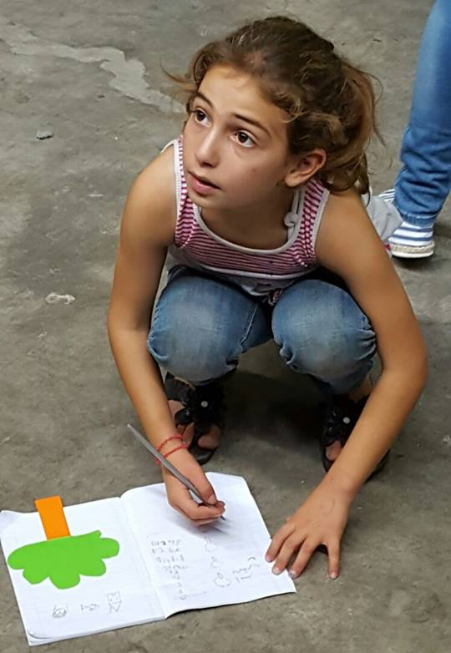
“I loved being part of the team. I think the variety of personalities on the team was great; I found myself drawing on the wisdom of different people at different points as a means to keep myself motivated, focused (and happy), so in this sense, the level of diversity was really crucial to my feeling of cohesion with everyone. I really felt part of something”
GAiN participant to Haiti

While on Project in Greece:

Accommodation and Meals

The accommodation will be a basic level. It is important to keep your living area clean and tidy throughout the trip and we ask you to treat your roommates with respect.

All main meals are included in the project, but you may want to bring additional snacks if you get hungry. We will share the preparation of food and will be taking it in turns to be available to help and to clear up after each mealtime. Each morning we will have breakfast in the accommodation and pack a lunch before leaving for the day’s activities.

General Rules & Advice
- Do not go off on your own without informing the project leaders.
- There will be shared rooms assigned to male and female, please do not go in the bedrooms assigned to the opposite sex.
- You will be expected to attend all team meetings during the project.
When working at the government hot-spots, it is very important to respect the people that we have come to serve!
- Please refrain from any activities that are offensive to the local community.
- Please do not take photographs without explicit permission from local staff.
- Smoking and drinking alcohol is not permitted.
For everything you do, always remember to be a good example, especially for the children.

EuroRelief Rules within the Camp

There are strict rules in camp Moria that we received from EuroRelief. We kindly ask you to stick to these rules. We are in the camp to help people, support Eurorelief and we would like us to be of service. You will have signed the Code of Conduct to agree to these rules.

All clothing must cover shoulders and ankles. Do not bring your best clothes, sometimes there are activities where you can quickly get dirty and the rain makes it very muddy. Most volunteers wear tennis shoes, sturdy sandals or boots.

We don’t want to put you off, but want you to be prepared. Most of the rules have resulted from experience of Eurorelief with former volunteers, but also results from the fact that Eurorelief needs to be careful in order to retain their current access to the camp and to follow the rules set out by the Greek authorities for volunteers to be allowed into the camp.

Cultural Sensitivity & Safety

Maintain at least the same level of personal security awareness as in the UK. There is a risk of petty theft in large towns. Keep a close eye on your valuables when out and about.

It is illegal to change money on the streets. You should change money only in recognised exchange shops, banks and hotels.

Advice for cultural sensitivity:

- Do say hello and greet people
- Be ready to assist in any capacity
- Do be consistent
- Be warm and friendly – even a smile goes a long way
- Do report anything suspicions
- Do ask any questions and seek to learn
- Say positive things about the people/place.

- Don’t swear or shout
- Don’t give hugs to opposite sex
- Don’t give out money
- Avoid showing favouritism
- Do not make assumptions or jump too quickly to conclusions about other cultures.

Sharing Stories…

“In April 2017, our group of nine volunteers with Agapé Student Life came from across the UK to Thessaloniki, to join the GAiN project not knowing fully what to expect. We travelled to Greece with the intention of providing our help to the refugees stuck in Greece, but were told that the situation on the ground constantly changes, and we would find out how we could help when we got there.
We arrived to a former army airfield, and the first thing we saw was a children’s playpark, something that none of us expected. As we began a quick tour, it was clear that the children were the life and soul of the camp – and often a source of much entertainment. We began our designated tasks, including building beds frames, distributing them and fridges to families, and decorating the bathroom containers with the help of some of those living on the camp. Throughout our time heard stories from many of the families and their plans for the future.

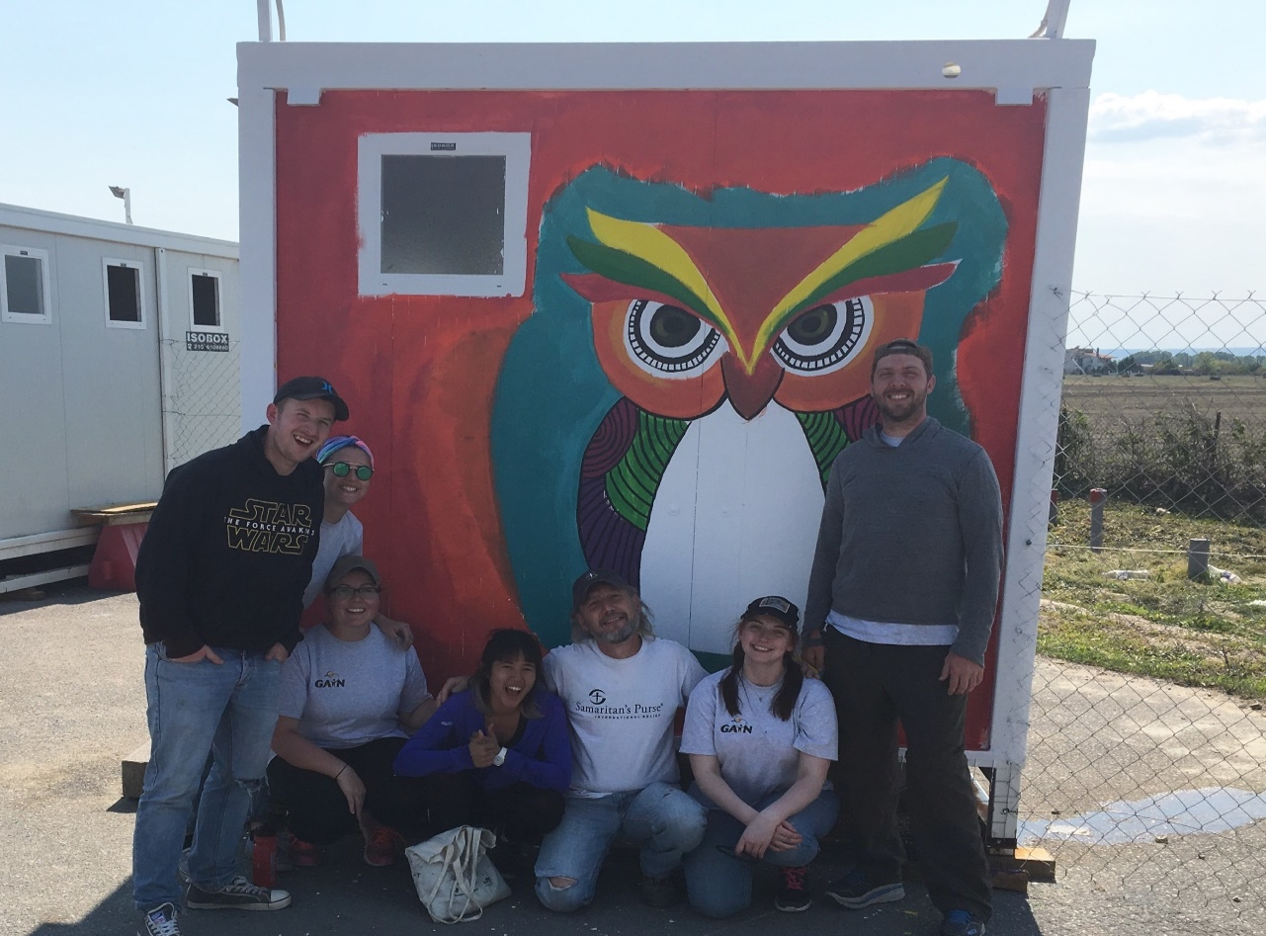

The experience that stood out most to me involved a former Art teacher who had fled from Syria, and had sent his family ahead to Germany. He did not speak any English, but was focused on learning German with the intention of finding work when he joins his family. He was quite stern for our first few interactions, but as he painted his face softened, and it seemed to bring him peace.
On our last day, half of the group helped teaching English and First Aid at a refugee centre in the city, with families who had been moved into more permanent accommodation. While the conditions in the camp and centre we visited were reasonably comfortable - in comparison to others we had heard about - we were aware of the hurt and trauma that so many of them had experienced to get that far. What gave us hope as we left, was the optimism and plans each family and individual had, and that their journey was not yet finished.

Appendix 1: Staying healthy on the project

- Immunisations

“It is recommended that you consult with your General Practitioner or Practice Nurse in advance of travel. They will assess your particular health risks before recommending vaccines and /or antimalarial tablets. This is also a good opportunity to discuss important travel health issues including safe food and water, accidents and insect bites. Many of the problems experienced by travellers cannot be prevented by vaccinations and other preventive measures need to be taken.” (www.fitfortravel.nhs.uk)

- Maintaining good hygiene

Take care to maintain good personal hygiene as this can help prevent illness on the project.
Wash hands before eating. There may not be effective sanitation in the camps and you will be at risk of catching infections after contact with people and the surroundings.

Alcohol gel can also be effective, but make sure your hands are free from dirt before using it.

- Water
The tap water is drinkable, but because of a high chlorine content in many places we recommend to drink bottled water.

- Pre-existing conditions
Please notify one of the project leaders about any pre-existing conditions that may have that make you more vulnerable to illness whilst on the project.

- Avoiding Injuries
Wear any safety equipment that you are provided with for practical tasks. Wear closed shoes when you are visiting in the camps.

If you are concerned about health and safety at any point, please check back with the project leaders.

Appendix 2: Project Legal Details
Global Aid Network (GAiN) UK is working in partnership with Agapé Ministries Ltd. The purchase of this product will be administrated through Agapé.

- Transportation

Your project will begin in Athens, you are responsible for the costs and booking of your flight into Athens airport. You will be met at the airport by your project leaders. Your flight costs to Lesbos and transportation within country are covered as a part of your project package. This will include airport transfers either by minibus or taxi, and passes to the city public transportation system (bus, train and metro). Other transportation may include car rental, bus, coach, train or taxi travel to local places to take part in the project activities.

b) Accommodation

Your accommodation will be either in rented private apartments which you will share with other same gender members of your team, or public hostels of similar levels to a UK youth hostel. In hostels the team will always be housed in private rooms that would only share with other same gender members of your team. The accommodation will be at a minimum level of a two star hotel.

Your accommodations will always provide private rooms for the group, washing facilities, bedding and meeting space.

c) Meals/Food

Your meals will be paid for as part of the team expenses for our stay in Greece. On the days when we are not having lunch provided as a team you will receive per diem cash set at a level deemed appropriate to the local area.

d) Itinerary

It is your responsibility to arrange and book flights to Athens to arrive on Friday 8th Feb 2019; your flight to Athens is not included as part of the cost of the project. Exact time for the start of the project will be confirmed once you are offered a place on the project.

Exact time for the start of the project will be confirmed once you are offered a place on the project.

Your induction will take place in country on the day of your arrival.

You will spend the remainder of your project based in and around the city to which you are applying before returning to Athens on Saturday 16th February 2019, or later should you wish to extend your travel to include additional personal travel. Your project and our responsibility end when you are dropped off at the local airport or onward travel connection arranged by agreement with your project leaders.

e) Passport requirements and potential health risks

Greece: As a UK citizen only your passport is required to enter Greece.

While in Greece you will not consume the tap water, you should only drink bottled water purchased from reputable persons/places. You should consult your local travel nurse for any vaccine that may be required based on the nature of the work and communities you will be working amongst.

f) Costs and payment

Your full payment is due two weeks before departure for the Project (£570 in total).

£100 NON-REFUNDABLE DEPOSIT RECEIVED within seven days of being accepted on the project
Final Balance for Full Payment two weeks before departure (see invoice for payment method).

g) Minimum numbers

There is a minimum number of six participants required for this Project. You will be travelling as part of a team along with Agapé and GAiN staff.

h) Travel delays

Any delays will be handled by your team leaders in conjunction with the staff responsible for the project both in the UK and in your host country. You will have full travel insurance cover as a part of your package which will be used in the event of delays. Accommodation and further per diem will be provided where required in the event of delays.

i) Security and liability of Agape

Agapé is covered by International Passenger Protection Insurance. This insurance covers the traveller in the case that Agapé becomes insolvent before or during a project.
In accordance with "The Package Travel, Package Holidays and Package Tours Regulations 1992" all passengers booking with Agape Ministries Ltd are fully protected for the initial deposit and subsequently the balance of all monies paid to us, including repatriation if required, arising from cancellation or curtailment of your travel arrangements due to the insolvency of Agape Ministries Ltd. There is no requirement for Financial Protection of day trips, and none is provided.

This insurance covers domestic flights, accommodation, in-country travel and associated costs. This insurance DOES NOT cover any international flights provided as part of the package.

Consumer aware: Your booking is insured by IPP Ltd and its panel of insurers. This insurance is only valid for passengers who book and pay directly with/to Agape Ministries Ltd. This Insurance has been arranged by International Passenger Protection Limited and underwritten by Certain underwriters at Lloyd’s. For further information please go to www.ipplondon.co.uk

All our travellers will also be covered by travel insurance arranged by us.

Appendix 3:
CONTACTS AND TELEPHONE NUMBERS

GAiN UK, c/o Agapé
167 Newhall Street, Birmingham, B3 1SW
E-mail: sarahpatel@globalaidnetwork.org.uk
Tel: 0121 765 4404

You may be able to use your mobile phone while you are there. Check with your service provider for tariff information.

In Case of Emergency
In the unlikely case of emergency, relatives will be able to get in touch with you through the emergency coordinator in the UK (below). There will also be an emergency coordinator on the project and the project leaders will have all the details.

UK Emergency Contact

UK Crisis Manager Contact Number: +44 (0) 121 348 7589

British Embassy
1, Ploutarchou St.
106 75 Athens
Tel: +30 210 7272 600

American Embassy
91 Vasilisis Sophias Ave
10160 Athens, Greece
Phone: 30-210-721-2951

South African Embassy
Leof. Kifissias 60
Marousi 151 25
Athens
Tel: +30 210 617 8020

Flights (complete once your flights are booked)
Outbound:

Inbound:

Please pass these details on to a relative who will be able to contact you in the event of an emergency through our emergency coordinator.

